Computer Simulator Simple Documentation

Introduction:
This document describes how to use our simulator in simple steps. The document is split into five sections:
- Introduction
- How to launch the Simulator
- What is the console layout
- How to operate the simulator from the console.
- User’s Bit-Instruction Manual
- Running a Program
This document will evolve to include additional steps as the simulator project progresses through the four planned phases of agile development.

How to launch the Simulator?
- Please make sure JAVA 1.8 or later is installed.
- Download the JAR file and boot program file
- The boot program file and the JAR file need to be in the same directory
- Double-click the JAR file to launch the console

What is the console layout?

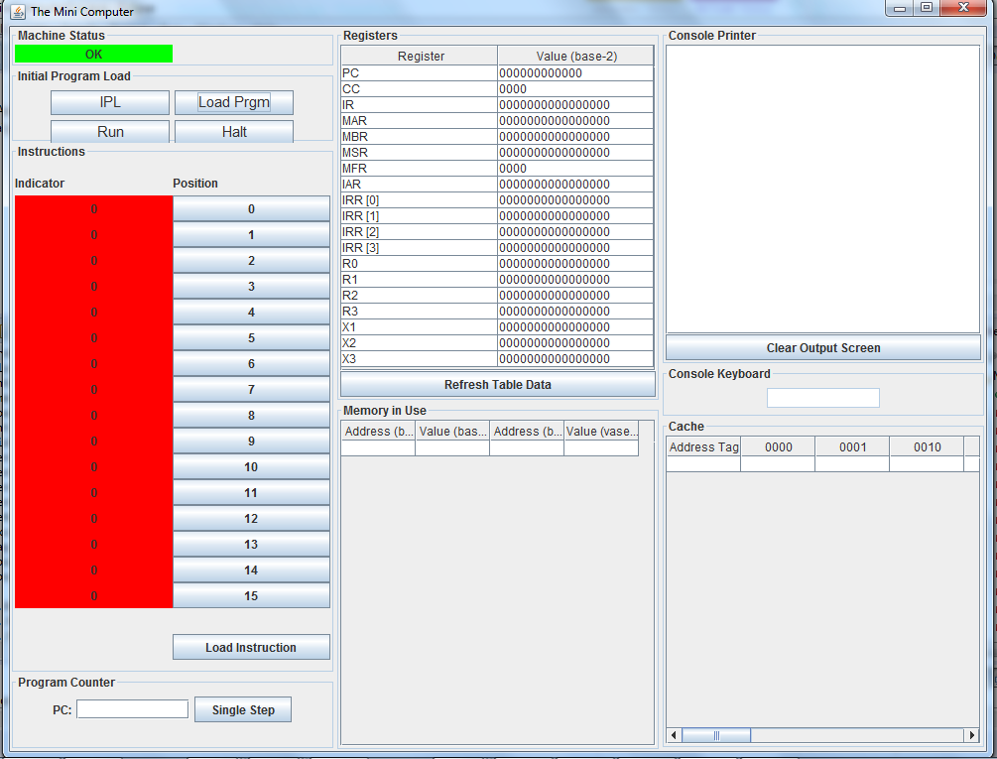

Our mini-computer has a graphical user interface (GUI) console. It is split into eight panels:
- Machine Status
  - Green = OK
  - Red = Fault/Trap (also displays fault code id)
- Initial Program Load (IPL)
  - Initial Program Load (IPL) – Contains the initial booting sequence options by activating the IPL button.
  - Load Program (Load Prgm) – Browse for a file location to load. The file should be a “.txt” format file, which should be in binary code as per specifications of this mini-computer. Loads program into memory (Starting at address 30), IPL should be pressed before pressing this button.
  - Run – This runs the loaded program. Executes the instruction pointed to by PC until either a HLT instruction is encountered or the user presses the Halt button on the GUI
  - Halt – The Halt button will stop the execution of any program that is running and return control to the user interface.
- Instructions – the console allows one 16-bit instruction to be input manually from the console.
- Program Counter – Allows the user to specify the program counter to single step
- Registers – displays the register and the value contained within the register
  - Refresh Table Data button – allows for manual refreshing
- Memory in Use – displays the address and value stored in memory in base-2 and base-10 notation.
  - Refresh Table Data button – allows for manual refreshing
- Console Printer – displays output
  - Clear Output Screen button
- Console Keyboard – is used for entering input.
  - The console keyboard will only accept letters, digits, and the Enter key, and only when the current instruction is IN
  - Enter key - used when the entire number/word has been entered by the user
- Cache – Displays cache
  - Each row is a cache line
  - The header row says Address Tag, followed by the permutations for the 4 bits that could follow the Address Tag to make up the entire 16-bit address

How to operate the simulator from the console.

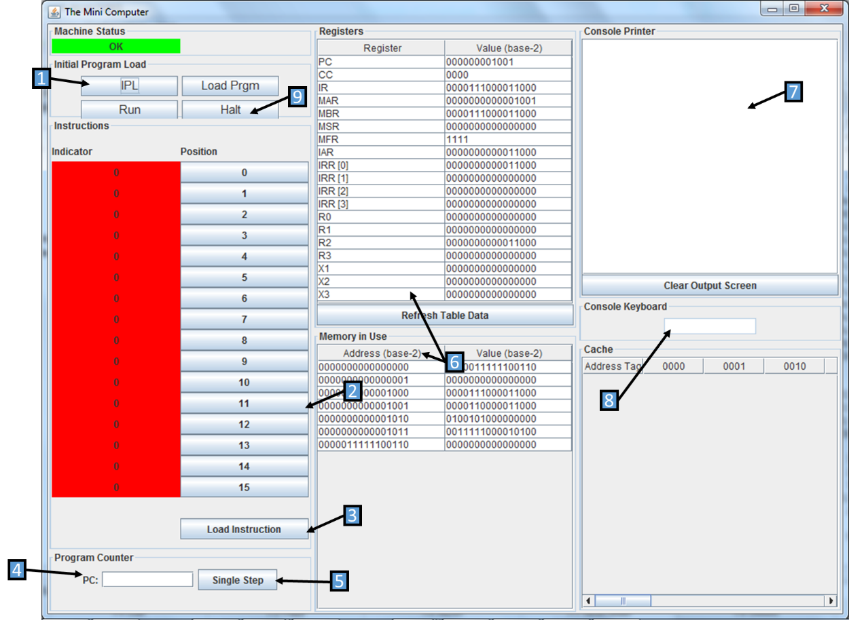
/////////

Step 1: From the coStep 1: From the console the minicomputer simulator can be launched by activating (clicking) the IPL switch. This IPL switch executes the boot program, which loads values into memory and registers (see label 6 for memory and register values).
Step 2: Instructions to the minicomputer can be entered into the instruction panel by activating bit-toggles (i.e. clicking buttons enumerated from 0-15). A green light indicates the corresponding bit position’s inclusion into the instruction. The user manual explains the available commands and basic bit-instruction usage.
Step 3: Activating the ‘Load Instruction’ will load the operator’s instruction into the minicomputer. Note: The default location for console instructions is “000000000110”
Step 4: From the Program Counter Panel the operator can elect to execute step-by-step instructions that have been loaded into the computer. The PC should contain the address of the instruction to be executed.
Step 5: Activate the Single Step button to execute the instruction.
Step 6: Observe the effect of your bit instruction in the minicomputer’s Registers and Memory.
Step 7: The user will be able to see output to the console in the Console Printer.
Step 8: While the console keyboard is used for entry, the enter button is used to finalize submission of inputs. Please note that you should carefully enter each character – there is no backspace functionality.
Step 9: To return control back to the console the Halt button can be used to interrupt a program running.

User’s Bit-Instruction Manual
Instructions for the minicomputer and the accompanying options for that instruction are broken down by the bit-position ranges in the figures and tables below. The Opcodes are the basic instruction options for the minicomputer. The general purpose register (R) will be used if an Opcode indicates a Load from register, or Store to register instruction. The index register (IX) will be used if an Opcode specifies a Load from index, or Store to index instruction. The indirect addressing indicator (I) tells the Opcode how to interpret the instruction’s address field. If I=0 then the Opcode will read the address value directly. However, if I=1 then the Opcode field will be a pointer to another address location.
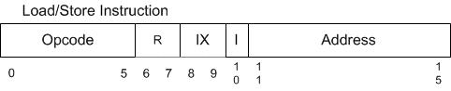
The basic interpretation of the bit-wise instruction can be summarized in the table below.

Field | #Bits | Description
Opcode | 6 | Specifies one of 64 possible instructions;  Not all may be defined in this project
R | 2 | Specifies one of four general purpose registers; may be referred to by R0 – R3
IX | 2 | Specifies one of three index registers; may be referred to by X1 – X3. O value indicates no indexing.
I | 1 | If I =1, specifies indirect addressing indicator; otherwise, no indirect addressing.
Address | 5 | Specifies one of 32 address locations in memory

The currently available instruction OpCodes are as defined below.
OpCode₂ | Instruction* | Description
000001 | LDR r, x, address[,I] | Load Register From Memory
000010 | STR r, x, address[,I] | Store Register To Memory
000011 | LDA r, x, address[,I] | Load Register with Address
100001 | LDX x, address[,I] | Load Index Register from Memory
100010 | STX x, address[,I] | Store Index Register to Memory
001000 | JZ r, x, address[,I] | Jump If Zero
001001 | JNE r, x, address[,I] | Jump If Not Equal
001010 | JCC cc, x, address[,I] | Jump If Condition Code
001011 | JMA x, address[,I] | Unconditional Jump To Address
001100 | JSR x, address[,I] | Jump and Save Return Address
001101 | RFS Immed | Return From Subroutine
001110 | SOB r, x, address[,I] | Subtract One and Branch
001111 | JGE r,x, address[,I] | Jump Greater Than or Equal
000100 | AMR r, x, address[,I] | Add Memory To Register
000101 | SMR r, x, address[,I] | Subtract Memory From Register
000110 | AIR r, immed | Add Immediate to Register
000111 | SIR r, immed | Subtract Immediate from Register
*[,I] = the Boolean indicator for using indirect addressing

OpCodes that are register to register use the following user entry pattern.
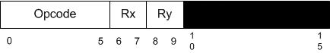
The currently available instruction OpCodes are as defined below.
OpCode₈ | Instruction | Description
010000 | MLT rx,ry | Multiply Register by Register
010001 | DVD rx,ry | Divide Register by Register
010010 | TRR rx, ry | Test the Equality of Register and Register
010011 | AND rx, ry | Logical And of Register and Register
010100 | ORR rx, ry | Logical Or of Register and Register
010101 | NOT rx | Logical Not of Register To Register

OpCodes that are logical instruction use the following user entry format.
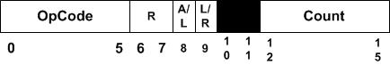
Where Register (R), Arithmetic/Logic (A/L), Left/Right (L/R), and Count are the options to perform the shift or rotate operation.
OpCode | Instruction | Description
011001 | SRC r, count, L/R, A/L | Shift Register by Count
011010 | RRC r, count, L/R, A/L | Rotate Register by Count

I/O Operations:
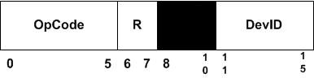
OpCode | Instruction | Description
110001 | IN r, devid | Input Character To Register from Device
110010 | OUT r, devid | Output Character to Device from Register
110011 | CHK r, devid | Check Device Status to Register

Running a Program
This mini-computer is configured to run 3 programs. The Boot Program is loaded and run via the IPL switch. The “Load Prgm” button allows for the loading of “Project1_bin.txt” and “Program2_bin.txt”. Any other program is not included under your license agreement. Please reach to your Simple Mini-computer sales representative if you are interested in our many other enhancements and products.

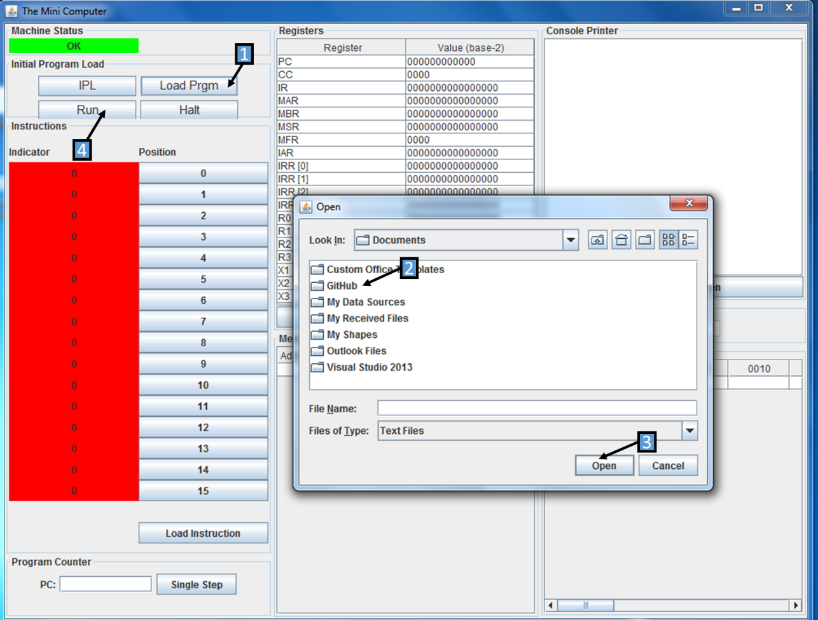
Step 1: Click Load Program button.
Step 2: Browse to the location of “Project1_bin.txt” or “Program2_bin.txt”.
Step 3: Load the desired program into memory.
Step 4: Run your program.
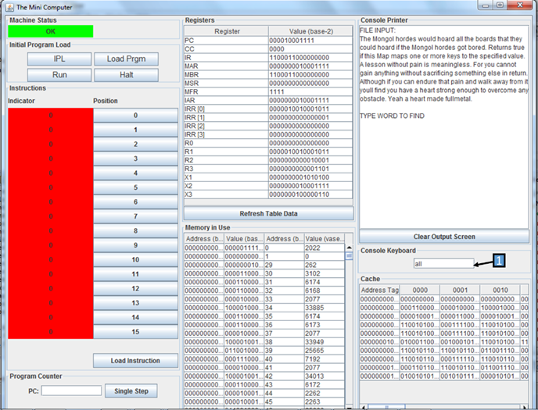
4
6
Note: If your program prompts for user entry, please use #7 Panel “Console Keyboard”, and slowly and carefully enter each character (i.e. there is not a backspace capability). Program 2 will search and find whole words (not substrings).

Use Case: Running Program 2 – Word Search
To assist the user in getting started and get familiar with the console layout of the simple computer we will guide you through the setup and execution of running program 2 – word search. As mentioned in the above section on loading a program you will want to:
Step 1: Click Load Program button.
Step 2: Browse to the location of “Program2_bin.txt”.
Step 3: Load “Program2_bin.txt”.
Step 4: Within the same directory as “Program2_bin.txt” create/edit a file labeled “prgm-2-input.txt.”
Step 4.1: “prgm-2-input.txt” should contain 6 sentences that you’d like to search for specific word position within the file (e.g. 4th word in the 3rd sentence is the searched word, “bananas”).
Step 5: Click Run button.

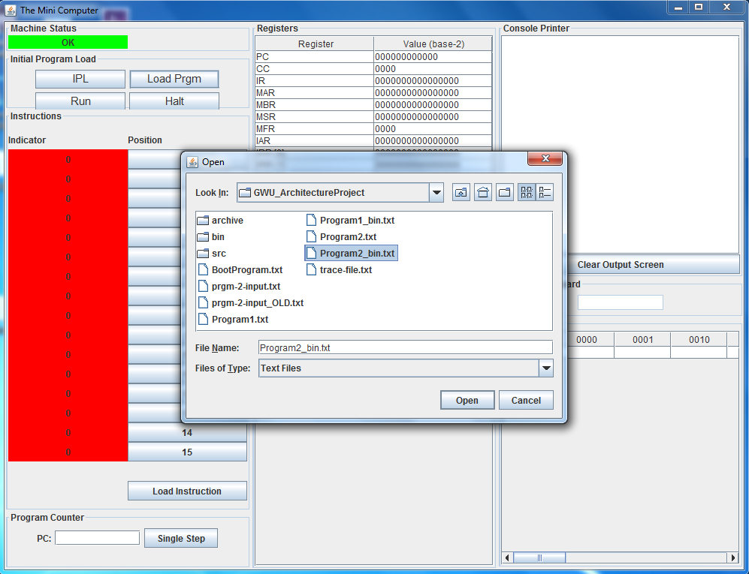
Step 6: Slowly type on the console keyboard a word you would like to search for in the “prgm-2-input.txt” file, and then hit enter on your keyboard.

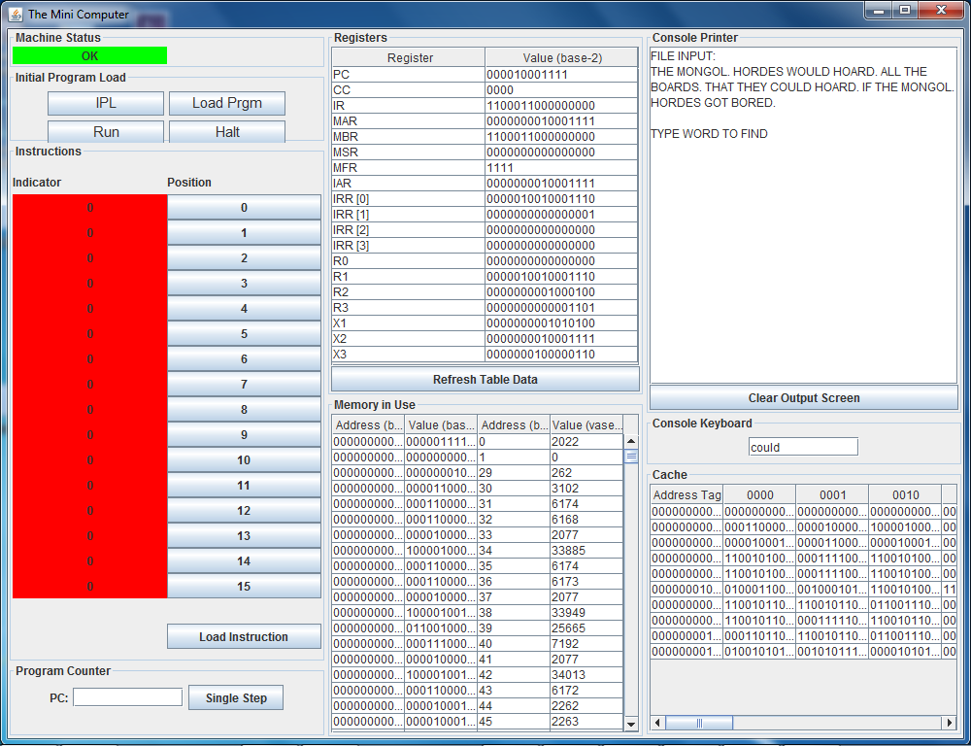
The program will return the sentence and word position of the first instance of the word you entered.
WARNING: Typing too quickly may cause read errors by the console. It also will increase the likelihood of mistyping a word – this console does not permit backspace, delete, or editing functionality once a character has been entered.
In the event that an entry error or machine-read error occurs, some steps the user can take are:
- Press the “HALT” button
- Press the “Clear Output Screen” button
- Retry loading the program (See steps 1-6 for details)
  - Press Load Prgm
  - Press Open
  - Press Run
  - Retype your search word carefully

WARNING: If the word is not found within “Program2_bin.txt” the user will not be prompted with a result, nor will the user be prompted with a ‘word not found’ result. So, if the user is fairly sure the word they are searching for does indeed exists within “Program2_bin.txt”, then the user should follow these error precaution steps and carefully enter their search parameters.

WARNING: Entering a partial word may result in inconsistent results, as currently implemented. (e.g. searching for “HEAR” in a file that contains “HEART” may return the word position results for HEART. However, looking for “EAR” will not find “HEART”. Please be cautious of this feature.)

